Python Lab Exercise

Exercise No:1
Date:12/10/2020

________________________________________________________________________________________

AIM: To write a Python program to print the calendar of a given month and year.
PROGRAM:
import calendar
year=int(input())
month=int(input())
count=0
n=year
while(n>0):
count=count+1
n=n//10
if(month>12 or count!=4):
print("Invalid Input ")
else:
print(calendar.month(year ,month))

LINK:

https://github.com/pankaj230/Exe1/blob/main/Exercise%201.zip

OUTPUT

2012
6
June 2012
Mo Tu We Th Fr Sa Su
1 2 3
4 5 6 7 8 9 10
11 12 13 14 15 16 17
18 19 20 21 22 23 24
25 26 27 28 29 30

RESULT: : Python program to print the calendar of a given month and year is written and output is verified

Exercise No:2
Date:12/10/2020

_____________________________________________________________________________________

AIM: To Write a Python function countX(lst, x) to count the number x in a given list of numbers.
PROGRAM:
def countX(lst, x):
count= 0
for ele in lst:
if ele == x:
count= count+1
print(count)

lst =[]
n = int(input())
for i in range(0,n):
ele = int(input())
lst.append(ele)

x = int(input())
countX(lst, x)

LINK:
https://github.com/pankaj230/Exe1/blob/main/Exercise%202.zip
OUTPUT:
Input: 9
8
6
8
10
8
20
10
8
8
8
output (numbers)---
5

RESULT: Python function countX(lst, x) to count the number x in a given list of numbers is written and output is verified

Exercise No:3
Date:12/10/2020

_________________________________________________________________________________________

AIM: To write a Python program to remove and print every second number from a list of numbers until the list becomes empty

PROGRAM:
def removeThirdNumber(int_list):
position= 2-1
index=0
len_list=(len(int_list))
while(len_list>0):
index=(position+index)%len_list
print(int_list.pop(index))
len_list -= 1
n=int(input())
int_list=[]
for i in range(n):
int_list.append(int(input()))
removeThirdNumber(int_list)

LINK:
https://github.com/pankaj230/Exe1/blob/main/Exercise%203.zip

OUTPUT:
Input ---
4
8
6
8
10
output (numbers)---
6
10
8
8

RESULT: Python program to remove and print every second number from a list of numbers until the list becomes empty is written and output is verified.

Exercise No:4
Date:12/10/2020

_________________________________________________________________________________________

AIM: Python program (function) to print a single string from two set of strings received from user and swap the first two characters of each string.

PROGRAM:
def convert(s):
new=""
for x in s:
new += x
return new

a=input()
b=input()
s1=a.strip()
s2=b.strip()
if(len(s1)>=2 and len(s2)>=2):
t1=list(s1)
t2=list(s2)
c1=t1[0]
c2=t1[1]
t1[0]=t2[0]
t1[1]=t2[1]
t2[0]=c1
t2[1]=c2
s1=convert(t1)
s2=convert(t2)
print(s1,"",s2)
else:
print("Invalid")

LINK:
https://github.com/pankaj230/Exe1/blob/main/Exercise%204.zip

OUTPUT:

python
java
jathon pyva

RESULT: Python program (function) to print a single string from two set of strings received from user and swap the first two characters of each string is written and output is verified.

Exercise No:5
Date:12/10/2020

_____________________________________________________________________________________________

AIM: To write a Write a Python function to print missing characters to make string pangram.

PROGRAM:
a=input()
a=set(a.strip())
a.remove(chr(32))
b="abcdefghijklmnopqrstuvwxyz"
b=set(b)
b=b.difference(a)
b=list(b)
b.sort()
print("".join(b))

LINK:

https://github.com/pankaj230/Exe1/blob/main/Exercise%205.zip

OUTPUT:

the quick brown fox jumps over the lazy
dg

RESULT: Python function to print missing characters to make string pangram is written and output is verified.

Exercise No:6
Date:12/10/2020

_____________________________________________________________________________________________

AIM: To predict the output of the tuple exercise

PROGRAM:
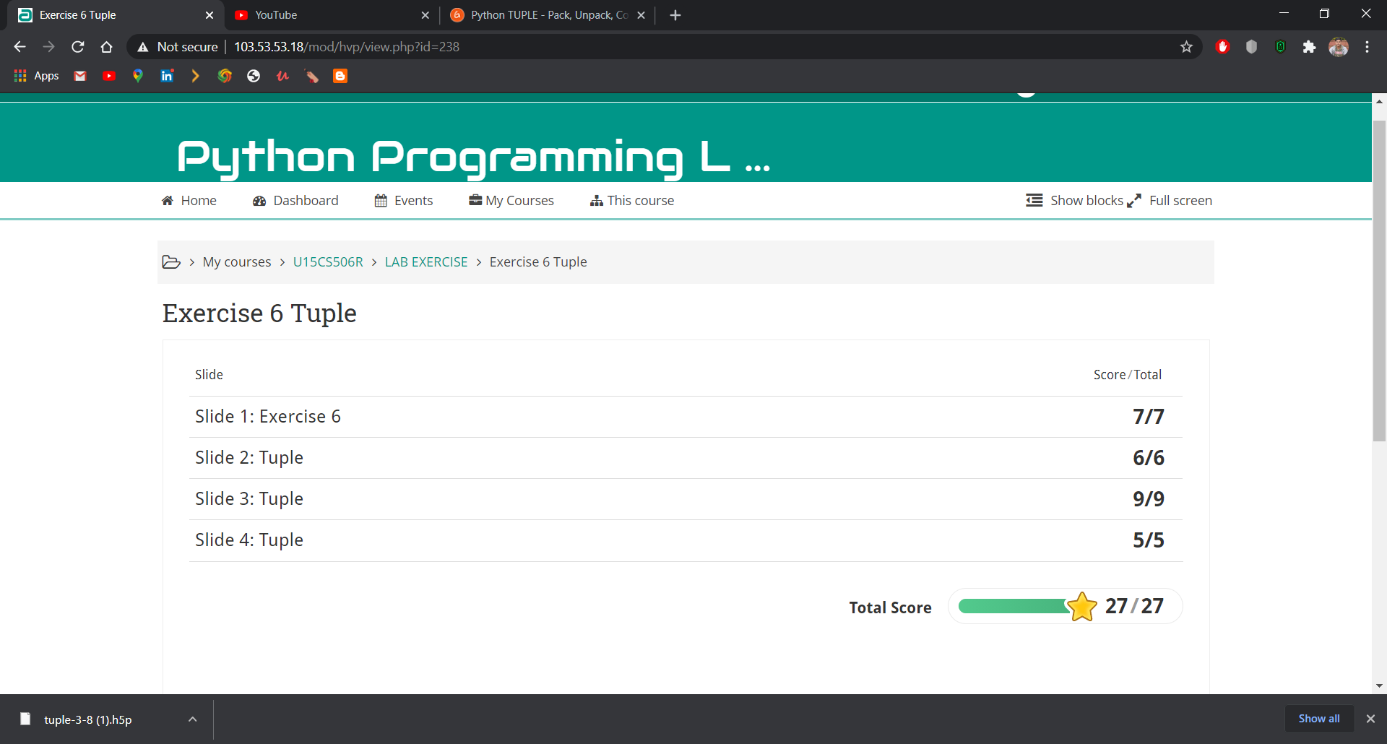

LINK:

https://github.com/pankaj230/Exe1/blob/main/Exercise%206%20Tuple%20-%20Google%20Chrome%2014-10-2020%2009_08_39.png

RESULT: Prediction the output of the tuple exercise was done and output was verified.

